Q: Do you have any evidence that any molecules passed from the beaker into the bag?
Yes. The starch turned purple, suggesting that the iodine moved into the dialysis tubing, causing the chemical reaction.

Q: Do you have any evidence that molecules moved from inside the bag to the outside?
Yes. Water moved out due to the greater volume of water.

Q: Which has larger molecules: starch or iodine-potassium-iodide?
Starch has larger molecules because it didn’t move. Iodine has smaller molecules as it moved into the bag.

Q: Use the description of osmosis to explain the changes that occurred in the experimental set-up.
- Water moves with the concentration gradient. This movement doesn’t require energy.
- Water molecules move with the concentration gradient until the water concentration is relatively equal either side of the dialysis tubing.

Q: If the cellulose bag containing the starch suspension were a model of the cell, which part of the cell would be represented by the cellulose bag itself?
The cell membrane.

Q: Predict what would happen if an isolated animal cell were placed in distilled water.
Water would move from the higher concentration in the distilled water compared to inside the cell (hypotonic solution). Therefore, water moves into the cell and the cell swells up.
Solute: The dissolved substances within the solvent.
Solvent: The substance that the solute is dissolved in.

Hypotonic solution: The outside has a higher concentration of solute/water than the inside of the cell (the egg in distilled water).
Hypertonic solution: The outside has a lower concentration of the solute than the inside of the cell (the egg in salt/saltwater).
Isotonic solution: There’s an equal concentration of solute and water across the cell membrane (the egg by itself).

Concentration of solutions:
- The higher the solute to solvent ratio, the more concentrated the solution is.
- The lower the solute to solvent ratio, the more dilute the solution is.
- The greater the difference between the concentration of substances either side of the cell membrane, the faster the exchange rate through the cell membrane.
Note: Substances generally move with the concentration gradient during passive transport mechanisms (such as diffusion, osmosis and facilitated diffusion).

Surface area to volume ratio:
- Cells are small so that they have a large surface area to volume ratio (SA:Vol).
- The greater the SA:Vol ratio, the more efficient and quicker the movement of substances through the cell membrane.

Fluid mosaic model:
“Fluid” because the molecules of which it’s made are constantly changing position.
“Mosaic” because it’s composed of many different kinds of molecules.
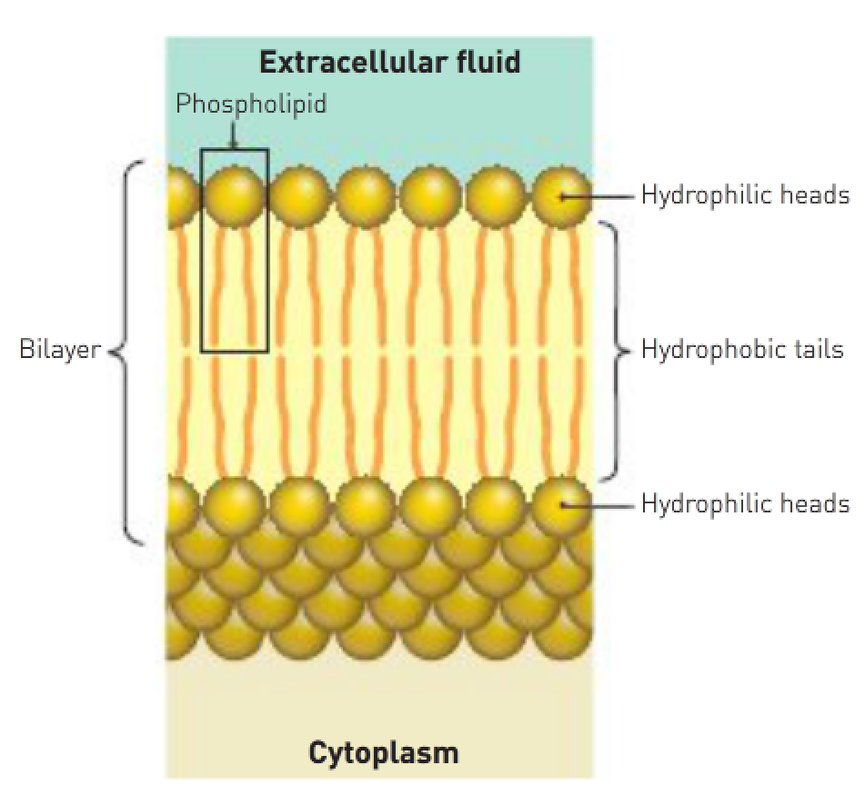

The main structure of the membrane is composed of phospholipid molecules (lipid molecules containing a phosphate group) arranged in 2 layers, known as a bilayer. Each phospholipid molecule has a hydrophilic head and a hydrophobic tail. Embedded within the phospholipid bilayers are a range of different proteins and cholesterol molecules.
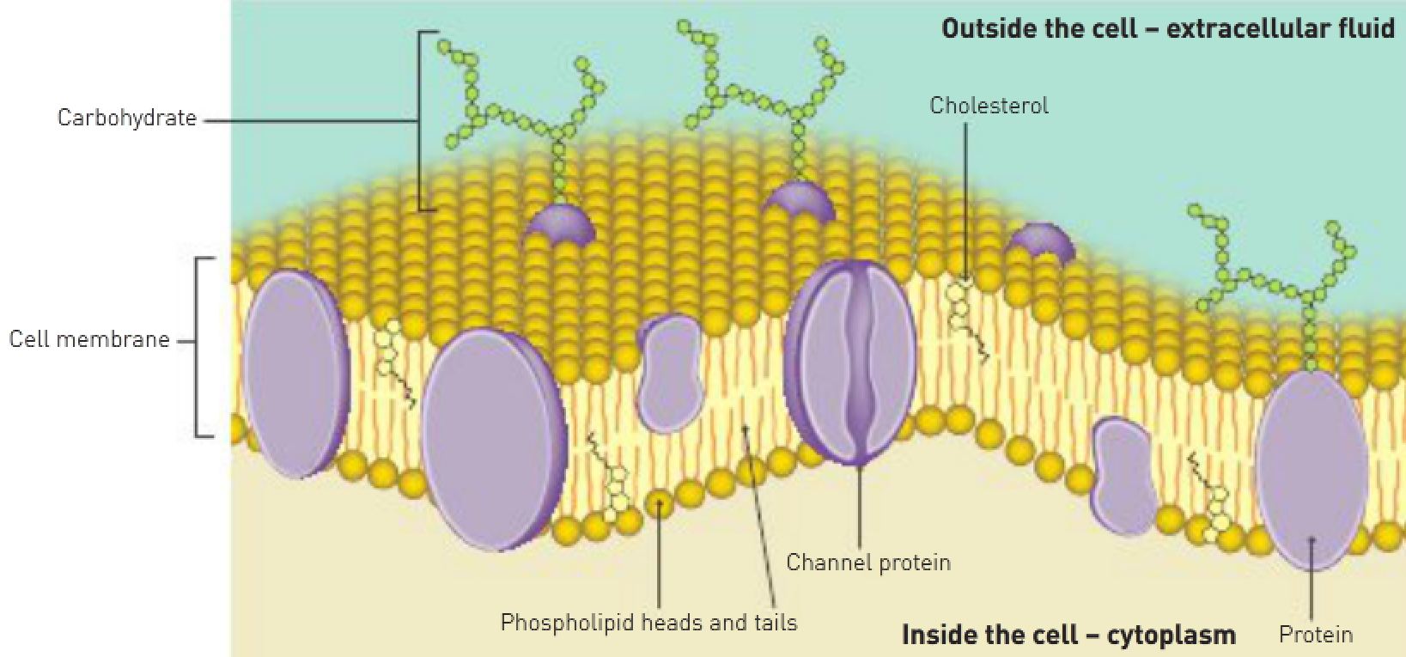
Cholesterol molecules are wedged between the phospholipids. Some protein molecules pass through the membrane from one side to another, while others are bound to the membrane surface. Channel proteins form a channel through the membrane and have a central pore that allows ions, water and other small molecules to pass through.

Functions of the cell membrane:
- Physical barrier – It separates the cell cytoplasm from the extracellular fluid.
- Regulation of the passage of materials – It controls the movement of materials into and out of the cell.
- Sensitivity – It’s the first part of the cell to be affected by any changes in the extracellular fluid.
- Support – The internal part is attached to the microfilaments of the cell’s cytoskeleton, thus giving support to the whole cell.

Membrane proteins:
- Receptor proteins.
- Channel proteins.
- Carrier proteins.
- Cell-identity markers.

Passive processes (e.g., diffusion, osmosis and facilitated diffusion) don’t require energy whereas active processes such as (active transport, endocytosis and exocytosis) require energy.

3 processes result in transport of materials into or out of a cell:
- Diffusion – A passive process resulting from the random movement of ions and molecules.
- Carrier-mediated transport – A process that requires special proteins in the cell membrane; may be passive or active depending on the exact nature of the mechanism.
- Vesicular transport – An active process in which materials are moved in membrane-bound sacs.

Diffusion:
- The spreading out of particles so that they’re evenly distributed over the space available.
- Small molecules move with the concentration gradient.
- Occurs in liquids or gases.
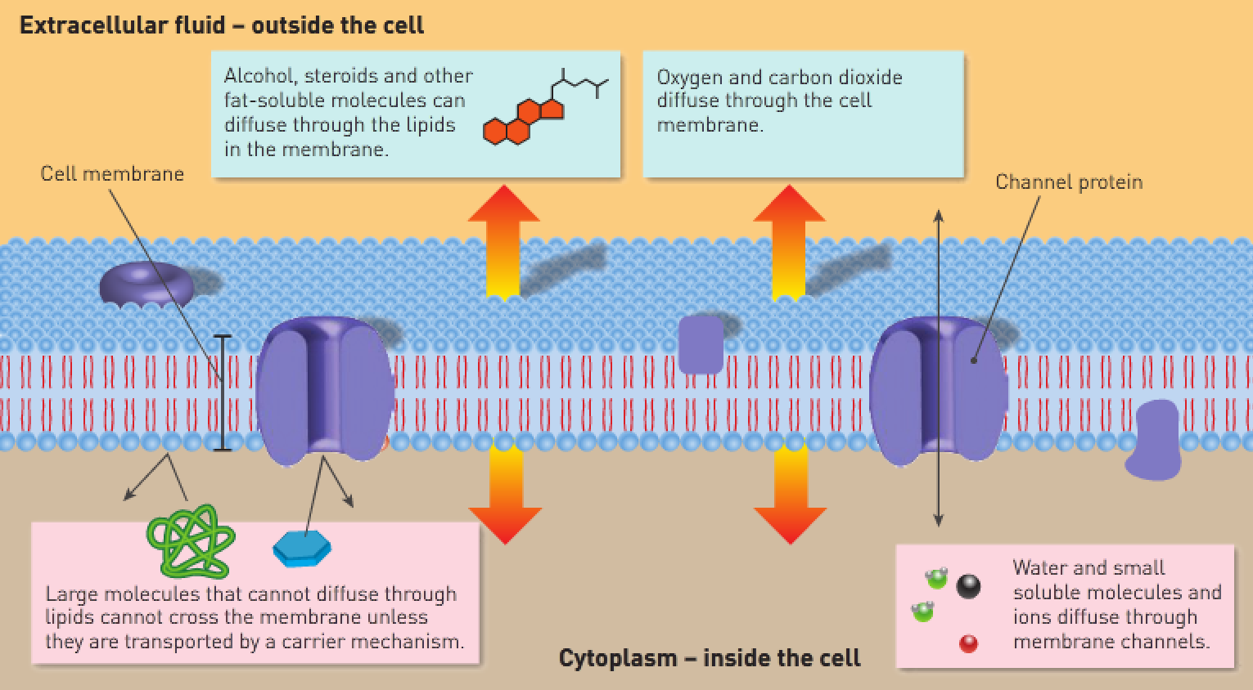
Osmosis:
- The diffusion of a solvent through a differentially permeable membrane.
- The diffusion of H₂O through channel proteins with the concentration gradient.
- H₂O molecules move one at a time through the channel protein.
- The concentration of water depends on how much solute is dissolved in the water.
- The higher the concentration of solute, the higher the osmotic pressure.
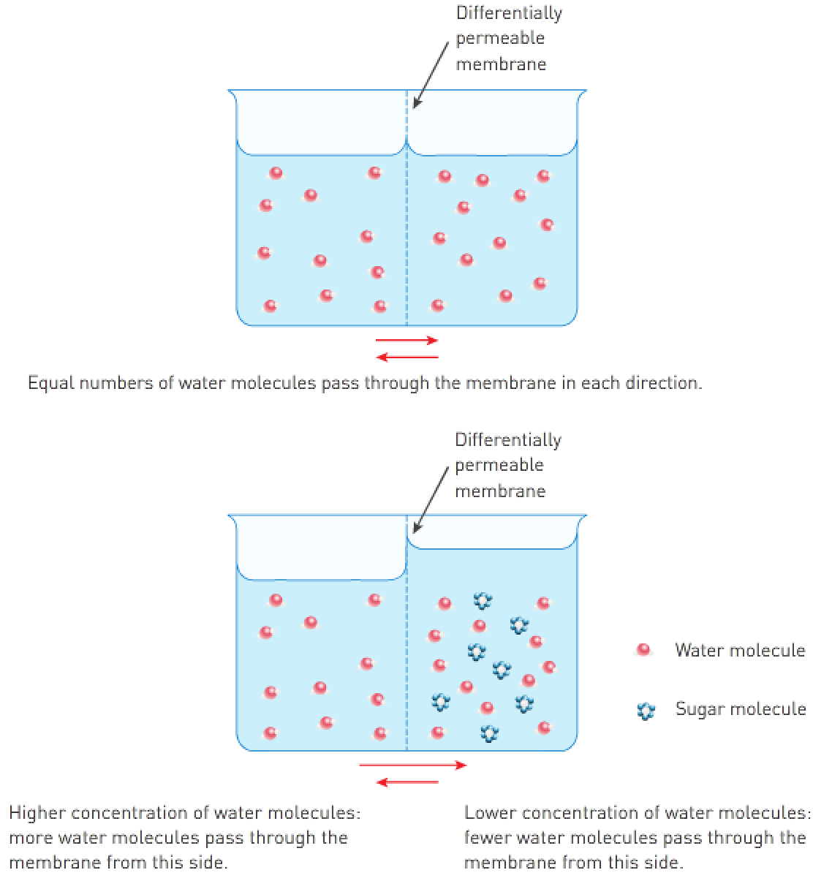
Carrier-mediated transport:
- Carrier proteins are specific.
- Carriers can become saturated.
- Carrier activity is regulated by substances e.g., hormones.
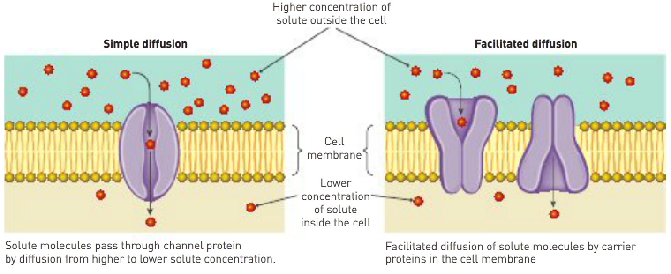
2 types of carrier-mediated transport:
- Facilitated diffusion.
- Active transport.

Facilitated diffusion:
- Large molecules bind to carrier proteins; the carrier protein changes shape to allow the molecules into or out of the cell.
- Passive process that moves with the concentration gradient.

Active transport:
- The movement of large molecules (e.g., glucose and amino acids) through a carrier protein.
- Active process that moves against the concentration gradient.
- The molecule binds to the carrier protein. The carrier protein changes shape and allows the molecule to drop through to the other side of the cell membrane.

Vesicular transport:
- Involves transporting large numbers of molecules in a vesicle.
- Active process that requires energy to form the vesicles.
- It’s advantageous because the other transport mechanisms can only move one molecule at a time.

Endocytosis:
- The engulfing of vesicles by the cell membrane. The membrane surrounds the vesicle and brings it into the cell.
- Phagocytosis – Brings solids into the cell. Pinocytosis – Brings liquids into the cell.

Exocytosis:
- The formation of a vesicle containing molecules inside the cell. The vesicle then moves outside the cell.
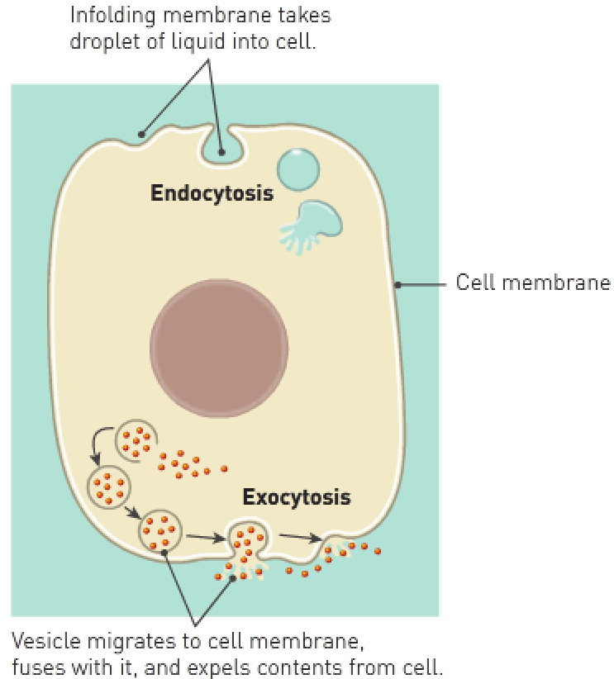
Type of transport: | Passive or active: | Substances transported:
Diffusion | Passive | H₂O, O₂, CO₂, alcohol, fatty acids, steroids, ions, lipids and soluble drugs.
Osmosis | Active | Water.
Carrier-mediated:  Facilitated diffusion | Passive | Glucose and amino acids.
Active transport | Active | Certain ions, glucose and amino acids.
Vesicular transport:  Endocytosis | Active | Cholesterol, iron ions, microorganisms and cell debris by certain cells.
Exocytosis | Active | Secretions e.g., mucus or digestive juices.

Microscope formulas:

Diameter (LP) x Magnification of LP objective
Diameter (HP)
Magnification of HP objective

Size of specimen = Diameter x Fraction of the diameter that the specimen occupies

Magnification of low power lens
= Diameter of high power FOV =

Magnification of high power lens

